Dear Client.
Please find attached our Specials News as well as January availability. Our special is on limited stock only, please order to avoid disappointment.
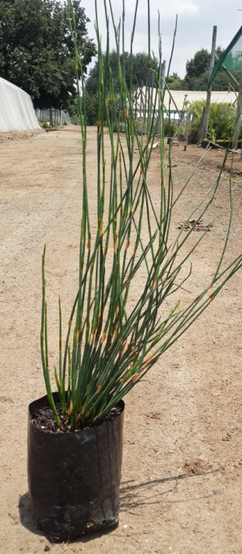
Chondropetalum tectorum 4 kg

Terms: ( including vat, availability: only 4000, COD only,
ex nursery, ends 28 January 2015)
Tel: 0828508019. www.duprins.co.za. email: duprins@absamail.co.za

